**EE 511**

**Simulation Methods for Stochastic Systems**

**Project #1 – Coins and Bootstraps**

**Name: Huliyar Sridhara Murthy, Kusha Sridhar**

**USC ID: 3954054993**

**Question 1 [Coins, Coins, everywhere…]**

Coin flipping is a [bernoulli process](http://en.wikipedia.org/wiki/Bernoulli_process).  This just means that all trials (flips) can have only two outcomes (heads or tails), and each trial is independent of every other trial.  What we’re interested in calculating what is the probability it will come up heads?  The obvious way to calculate this probability is simply to divide the number of heads by the total number of trials.

An experiment of tossing a fair coin 13 times was repeated 50 times and the results were recorded in a variable ‘heads’. This experiment was simulated by implementing it with a python code.

A scatter plot, histogram and running tally of the results of the experiment is plotted.

* The plots attached shows that the coin tossing experiment with ‘n’ independent Bernoulli trials follows a binomial distribution. Here as n is large and the probability of both heads and tails being approximately equal (np > 5 and nq > 5) – CLT approximation can be applied to the binomial distribution to get a binomial approximation for the CLT and thus the result was fairly normal (as can be seen from the histogram plot).
* The scatter plot is more like a discrete plot of the number of heads obtained in each experiment.
* The running tally of the (total # of heads / total # of coin flips), converges to 0.5 approximately which is evidence that the coin in consideration is fair.

The running tally is as shown:

[3, 12]

[3, 12, 19]

[3, 12, 19, 27]

[3, 12, 19, 27, 34]

[3, 12, 19, 27, 34, 42]

[3, 12, 19, 27, 34, 42, 51]

[3, 12, 19, 27, 34, 42, 51, 55]

[3, 12, 19, 27, 34, 42, 51, 55, 63]

[3, 12, 19, 27, 34, 42, 51, 55, 63, 70]

[3, 12, 19, 27, 34, 42, 51, 55, 63, 70, 75]

[3, 12, 19, 27, 34, 42, 51, 55, 63, 70, 75, 82]

[3, 12, 19, 27, 34, 42, 51, 55, 63, 70, 75, 82, 89]

[3, 12, 19, 27, 34, 42, 51, 55, 63, 70, 75, 82, 89, 97]

[3, 12, 19, 27, 34, 42, 51, 55, 63, 70, 75, 82, 89, 97, 104]

[3, 12, 19, 27, 34, 42, 51, 55, 63, 70, 75, 82, 89, 97, 104, 106]

[3, 12, 19, 27, 34, 42, 51, 55, 63, 70, 75, 82, 89, 97, 104, 106, 114]

[3, 12, 19, 27, 34, 42, 51, 55, 63, 70, 75, 82, 89, 97, 104, 106, 114, 124]

[3, 12, 19, 27, 34, 42, 51, 55, 63, 70, 75, 82, 89, 97, 104, 106, 114, 124, 130]

[3, 12, 19, 27, 34, 42, 51, 55, 63, 70, 75, 82, 89, 97, 104, 106, 114, 124, 130, 140]

[3, 12, 19, 27, 34, 42, 51, 55, 63, 70, 75, 82, 89, 97, 104, 106, 114, 124, 130, 140, 147]

[3, 12, 19, 27, 34, 42, 51, 55, 63, 70, 75, 82, 89, 97, 104, 106, 114, 124, 130, 140, 147, 152]

[3, 12, 19, 27, 34, 42, 51, 55, 63, 70, 75, 82, 89, 97, 104, 106, 114, 124, 130, 140, 147, 152, 160]

[3, 12, 19, 27, 34, 42, 51, 55, 63, 70, 75, 82, 89, 97, 104, 106, 114, 124, 130, 140, 147, 152, 160, 169]

[3, 12, 19, 27, 34, 42, 51, 55, 63, 70, 75, 82, 89, 97, 104, 106, 114, 124, 130, 140, 147, 152, 160, 169, 173]

[3, 12, 19, 27, 34, 42, 51, 55, 63, 70, 75, 82, 89, 97, 104, 106, 114, 124, 130, 140, 147, 152, 160, 169, 173, 182]

[3, 12, 19, 27, 34, 42, 51, 55, 63, 70, 75, 82, 89, 97, 104, 106, 114, 124, 130, 140, 147, 152, 160, 169, 173, 182, 185]

[3, 12, 19, 27, 34, 42, 51, 55, 63, 70, 75, 82, 89, 97, 104, 106, 114, 124, 130, 140, 147, 152, 160, 169, 173, 182, 185, 193]

[3, 12, 19, 27, 34, 42, 51, 55, 63, 70, 75, 82, 89, 97, 104, 106, 114, 124, 130, 140, 147, 152, 160, 169, 173, 182, 185, 193, 200]

[3, 12, 19, 27, 34, 42, 51, 55, 63, 70, 75, 82, 89, 97, 104, 106, 114, 124, 130, 140, 147, 152, 160, 169, 173, 182, 185, 193, 200, 204]

[3, 12, 19, 27, 34, 42, 51, 55, 63, 70, 75, 82, 89, 97, 104, 106, 114, 124, 130, 140, 147, 152, 160, 169, 173, 182, 185, 193, 200, 204, 212]

[3, 12, 19, 27, 34, 42, 51, 55, 63, 70, 75, 82, 89, 97, 104, 106, 114, 124, 130, 140, 147, 152, 160, 169, 173, 182, 185, 193, 200, 204, 212, 217]

[3, 12, 19, 27, 34, 42, 51, 55, 63, 70, 75, 82, 89, 97, 104, 106, 114, 124, 130, 140, 147, 152, 160, 169, 173, 182, 185, 193, 200, 204, 212, 217, 222]

[3, 12, 19, 27, 34, 42, 51, 55, 63, 70, 75, 82, 89, 97, 104, 106, 114, 124, 130, 140, 147, 152, 160, 169, 173, 182, 185, 193, 200, 204, 212, 217, 222, 229]

[3, 12, 19, 27, 34, 42, 51, 55, 63, 70, 75, 82, 89, 97, 104, 106, 114, 124, 130, 140, 147, 152, 160, 169, 173, 182, 185, 193, 200, 204, 212, 217, 222, 229, 235]

[3, 12, 19, 27, 34, 42, 51, 55, 63, 70, 75, 82, 89, 97, 104, 106, 114, 124, 130, 140, 147, 152, 160, 169, 173, 182, 185, 193, 200, 204, 212, 217, 222, 229, 235, 239]

[3, 12, 19, 27, 34, 42, 51, 55, 63, 70, 75, 82, 89, 97, 104, 106, 114, 124, 130, 140, 147, 152, 160, 169, 173, 182, 185, 193, 200, 204, 212, 217, 222, 229, 235, 239, 243]

[3, 12, 19, 27, 34, 42, 51, 55, 63, 70, 75, 82, 89, 97, 104, 106, 114, 124, 130, 140, 147, 152, 160, 169, 173, 182, 185, 193, 200, 204, 212, 217, 222, 229, 235, 239, 243, 250]

[3, 12, 19, 27, 34, 42, 51, 55, 63, 70, 75, 82, 89, 97, 104, 106, 114, 124, 130, 140, 147, 152, 160, 169, 173, 182, 185, 193, 200, 204, 212, 217, 222, 229, 235, 239, 243, 250, 253]

[3, 12, 19, 27, 34, 42, 51, 55, 63, 70, 75, 82, 89, 97, 104, 106, 114, 124, 130, 140, 147, 152, 160, 169, 173, 182, 185, 193, 200, 204, 212, 217, 222, 229, 235, 239, 243, 250, 253, 260]

[3, 12, 19, 27, 34, 42, 51, 55, 63, 70, 75, 82, 89, 97, 104, 106, 114, 124, 130, 140, 147, 152, 160, 169, 173, 182, 185, 193, 200, 204, 212, 217, 222, 229, 235, 239, 243, 250, 253, 260, 265]

[3, 12, 19, 27, 34, 42, 51, 55, 63, 70, 75, 82, 89, 97, 104, 106, 114, 124, 130, 140, 147, 152, 160, 169, 173, 182, 185, 193, 200, 204, 212, 217, 222, 229, 235, 239, 243, 250, 253, 260, 265, 271]

[3, 12, 19, 27, 34, 42, 51, 55, 63, 70, 75, 82, 89, 97, 104, 106, 114, 124, 130, 140, 147, 152, 160, 169, 173, 182, 185, 193, 200, 204, 212, 217, 222, 229, 235, 239, 243, 250, 253, 260, 265, 271, 277]

[3, 12, 19, 27, 34, 42, 51, 55, 63, 70, 75, 82, 89, 97, 104, 106, 114, 124, 130, 140, 147, 152, 160, 169, 173, 182, 185, 193, 200, 204, 212, 217, 222, 229, 235, 239, 243, 250, 253, 260, 265, 271, 277, 281]

[3, 12, 19, 27, 34, 42, 51, 55, 63, 70, 75, 82, 89, 97, 104, 106, 114, 124, 130, 140, 147, 152, 160, 169, 173, 182, 185, 193, 200, 204, 212, 217, 222, 229, 235, 239, 243, 250, 253, 260, 265, 271, 277, 281, 289]

[3, 12, 19, 27, 34, 42, 51, 55, 63, 70, 75, 82, 89, 97, 104, 106, 114, 124, 130, 140, 147, 152, 160, 169, 173, 182, 185, 193, 200, 204, 212, 217, 222, 229, 235, 239, 243, 250, 253, 260, 265, 271, 277, 281, 289, 295]

[3, 12, 19, 27, 34, 42, 51, 55, 63, 70, 75, 82, 89, 97, 104, 106, 114, 124, 130, 140, 147, 152, 160, 169, 173, 182, 185, 193, 200, 204, 212, 217, 222, 229, 235, 239, 243, 250, 253, 260, 265, 271, 277, 281, 289, 295, 301]

[3, 12, 19, 27, 34, 42, 51, 55, 63, 70, 75, 82, 89, 97, 104, 106, 114, 124, 130, 140, 147, 152, 160, 169, 173, 182, 185, 193, 200, 204, 212, 217, 222, 229, 235, 239, 243, 250, 253, 260, 265, 271, 277, 281, 289, 295, 301, 307]

[3, 12, 19, 27, 34, 42, 51, 55, 63, 70, 75, 82, 89, 97, 104, 106, 114, 124, 130, 140, 147, 152, 160, 169, 173, 182, 185, 193, 200, 204, 212, 217, 222, 229, 235, 239, 243, 250, 253, 260, 265, 271, 277, 281, 289, 295, 301, 307, 314]

[3, 12, 19, 27, 34, 42, 51, 55, 63, 70, 75, 82, 89, 97, 104, 106, 114, 124, 130, 140, 147, 152, 160, 169, 173, 182, 185, 193, 200, 204, 212, 217, 222, 229, 235, 239, 243, 250, 253, 260, 265, 271, 277, 281, 289, 295, 301, 307, 314, 319].

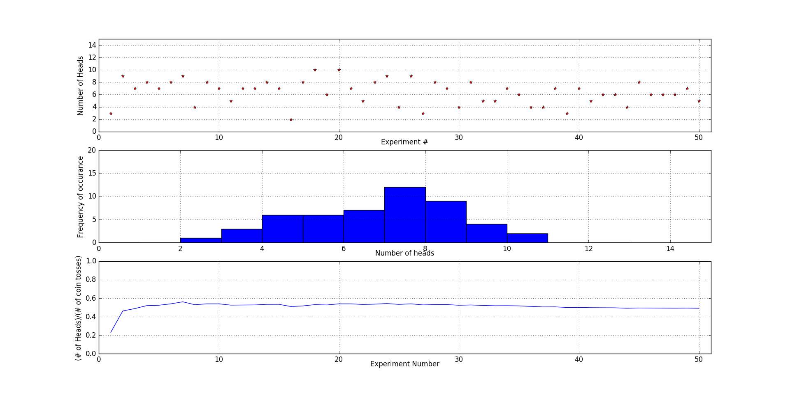Question 1 plot

**Question 2 [So Unfair]**

I bent the coin a significant amount to make it biased towards the probability of heads and tails and repeated the above experiment.

* It can be clearly seen that the distribution is no longer normal but the peak is shifted towards the right. This means that there were more number of heads that came up than the number of tails – which is a clear evidence that the coin is biased or unfair.
* Also from the plot of running tally, it is seen that the probability of heads is converging to around 0.6. The results indicate this fact more clearly:

[4, 11, 8, 8, 9, 10, 9, 7, 10, 11, 11, 10, 7, 8, 8, 10, 6, 8, 6, 6, 10, 10, 9, 11, 9, 10, 10, 7, 11, 10, 10, 6, 7, 9, 7, 9, 11, 9, 9, 7, 11, 10, 10, 2, 8, 11, 11, 9, 5, 11]

[0.3076923076923077, 0.5769230769230769, 0.5897435897435898, 0.5961538461538461, 0.6153846153846154, 0.6410256410256411, 0.6483516483516484, 0.6346153846153846, 0.6495726495726496, 0.6692307692307692, 0.6853146853146853, 0.6923076923076923, 0.6804733727810651, 0.6758241758241759, 0.6717948717948717, 0.6778846153846154, 0.665158371040724, 0.6623931623931624, 0.6518218623481782, 0.6423076923076924, 0.6483516483516484, 0.6538461538461539, 0.6555183946488294, 0.6634615384615384, 0.6646153846153846, 0.6686390532544378, 0.6723646723646723, 0.6675824175824175, 0.6737400530503979, 0.676923076923077, 0.6799007444168734, 0.6730769230769231, 0.668997668997669, 0.669683257918552, 0.6659340659340659, 0.6666666666666666, 0.6715176715176715, 0.6720647773279352, 0.6725838264299803, 0.6692307692307692, 0.6735459662288931, 0.6758241758241759, 0.6779964221824687, 0.666083916083916, 0.6649572649572649, 0.6688963210702341, 0.6726677577741408, 0.6730769230769231, 0.6671899529042387, 0.6707692307692308]

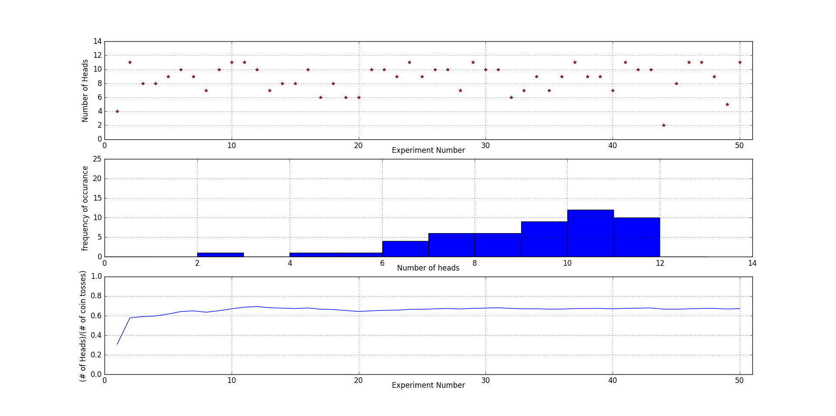Question 2 plot

**Question 3 [Gas Bootstrap Confidence Intervals]**